DBMS – ADVANCED SQL QUERY SYSTEM
SWIGGY INSTAMART E-COMMERCE DATABASE MANAGEMENT SYSTEM

Objectives
1. Implement subqueries and nested queries.
2. Find products above the average price.
3. Identify customers with maximum purchases.
4. Generate complex business queries.
5. Prepare advanced SQL reports.

1. Subqueries and Nested Queries
A subquery is a query written inside another SQL query.
The inner query is executed first, and its result is used by the outer query

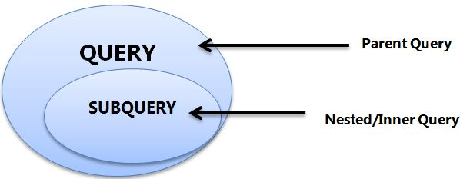

Basic Structure
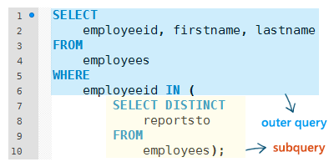

Types of Subqueries
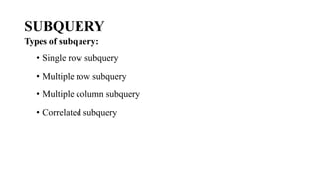

Example
Find orders whose amount is greater than the average order amount.
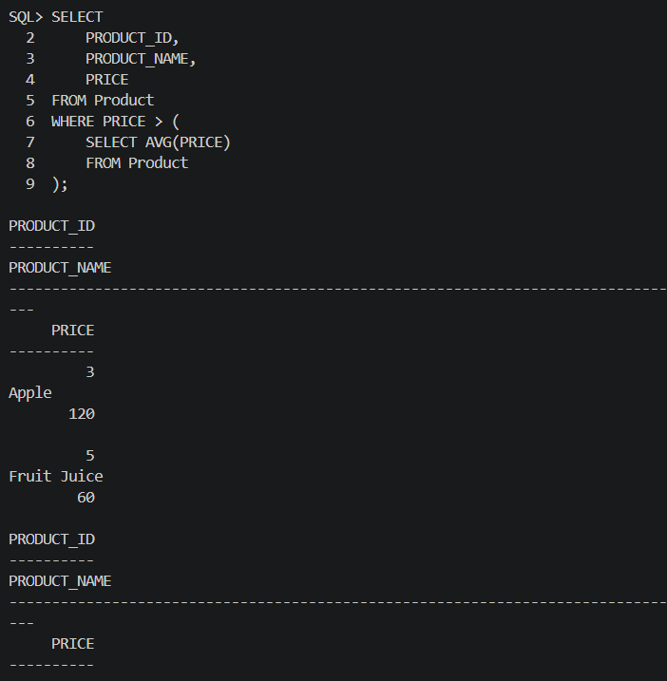

Explanation:
- The inner query calculates the average price of all products.
- The outer query displays products whose price is greater than the average price.
- It shows the Product ID, Product Name and Price of those products.

2. Find Products Above Average Price
To display products whose price is greater than the average price of all products.
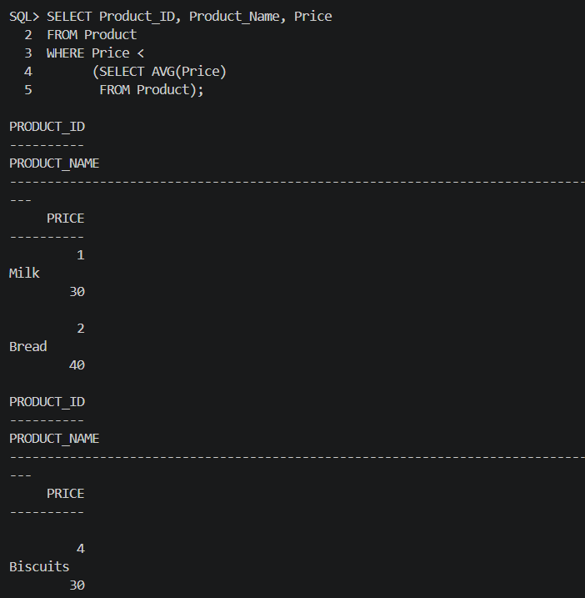

Explanation:
- The inner query calculates the average price of all products.
- The outer query displays products whose price is above the average price.

3. Identify Customers with Maximum Purchases
We can use SUM() along with a subquery to identify the customer who has the highest total purchase amount.
Step 1: Calculate Customer-wise Purchase
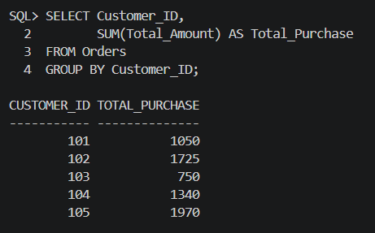

Step 2: Find the Maximum Purchase
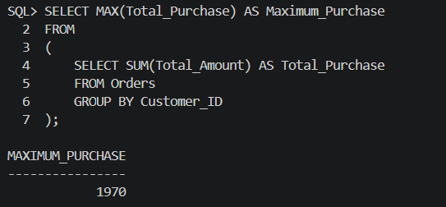

The inner query calculates the total purchase for each customer.
The outer query finds the maximum value among those totals
3.1 Display Customer Details with Maximum Purchase
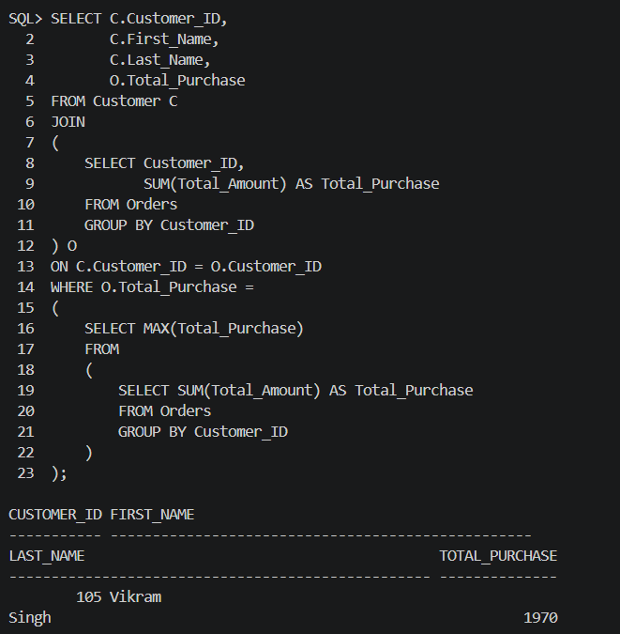

4. Complex Business Queries
To perform complex business-related queries using subqueries, joins and aggregate functions to analyse business data.

4.1 Customers Who Placed Orders Above Average Order Value
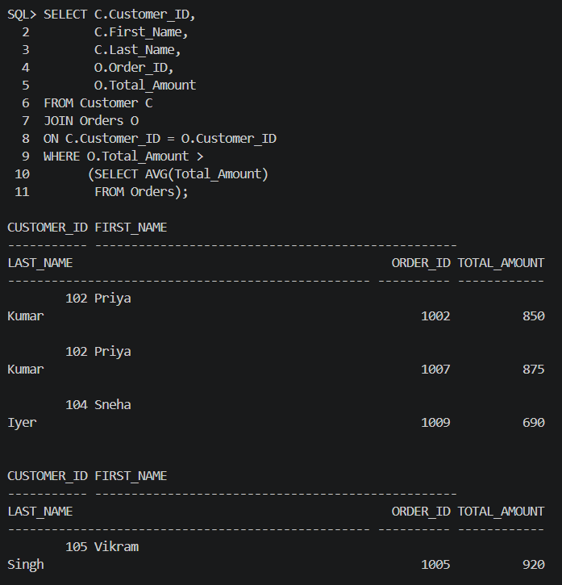

Purpose:
This query identifies customers who placed orders whose value is greater than the overall average order value. It helps the business identify high-value orders and understand customer purchasing behaviour.

5. Find Products Whose Sales Are Above Average
The total sales of each product can be calculated from Order_Item.

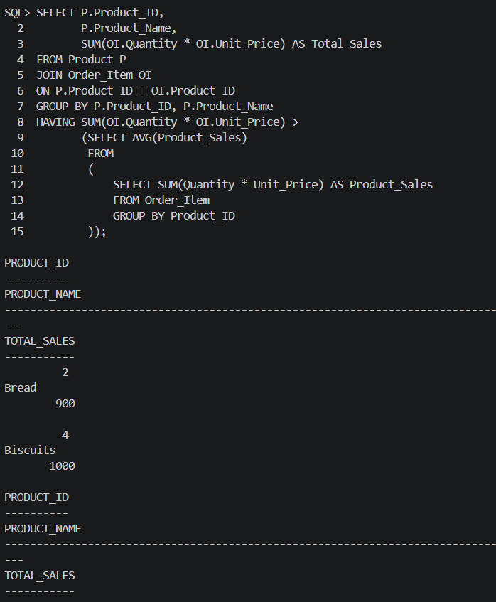

Purpose:
This query identifies products whose total sales are above average. It helps the business find the best-selling products and analyse sales performance.

6. Customer Purchase Report
A detailed customer purchase report can combine multiple tables.
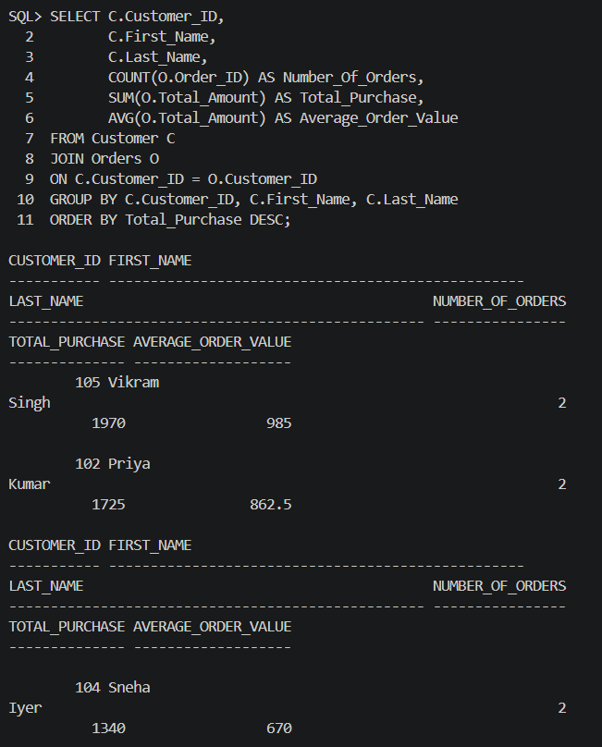

Report Contains:
- Customer ID
- Customer Name
- Number of Orders
- Total Purchase Amount
- Average Order Value

7. Advanced Product Sales Report
This report combines product and order item.

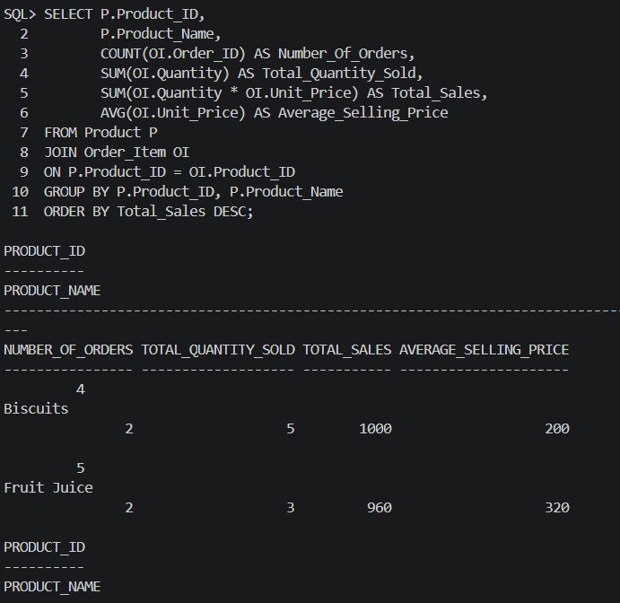

Purpose
This report helps the business identify:
• Number of orders for each product
• Total quantity sold
• Total sales
• Average selling price
• Products generating higher sales

8. Category-wise Advanced Sales Report
Category-wise sales can be generated by combining Category, Product, and Order_Item.


